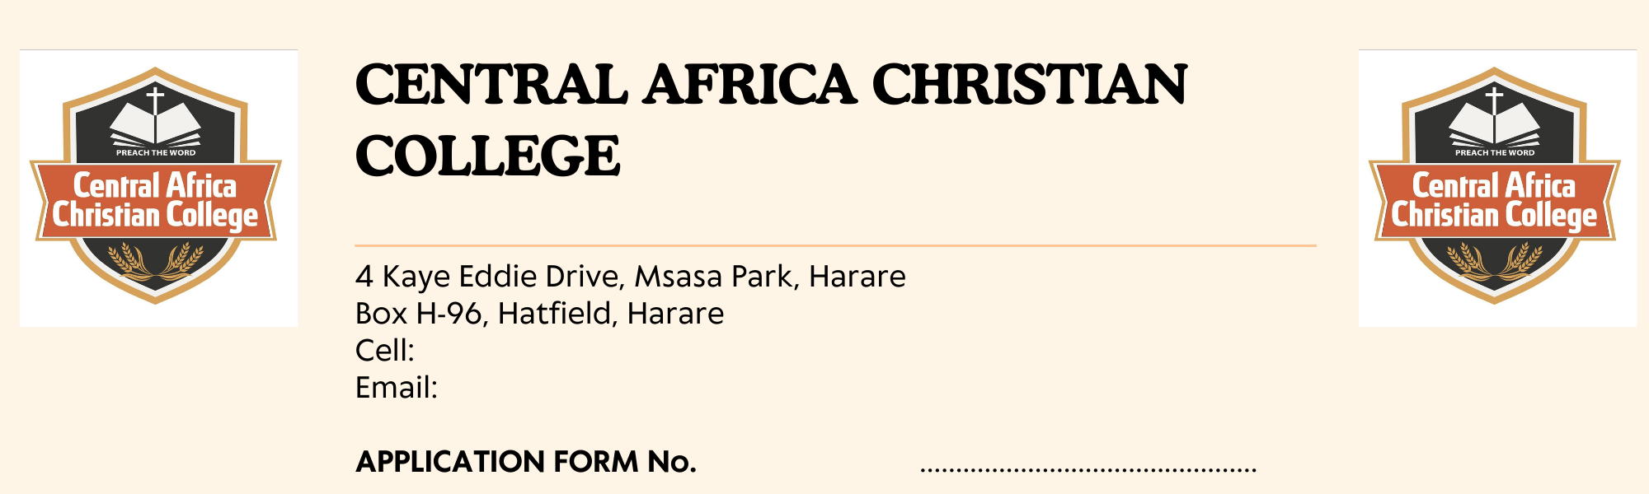
PLEASE COMPLETE IN FULL IN BLOCK LETTERS AND VERIFY THAT INFORMATION SUBMITTED IS CORRECT AND UP TO DATE

Choose the program you are applying for |  | Application Date: ....................
PROGRAM |  | TICK TO SHOW THE CHOSEN PROGRAM
Bachelor of Arts Honours Degree in Religious Studies and Philosophy
Diploma in religious Studies
Diploma in Theology
Certificate in Theology
PERSONAL | DETAILS
NAME

SURNAME

MARITAL STATUS

GENDER

AGE

WHICH CHURCH ARE YOU A MEMBER OF?

DO YOU HAVE DEPENDENTS (If yes give details including ages)

POSTAL ADDRESS

RESIDENTIAL ADDRESS

CELL:

EMAIL:

ATTACH A PASSPORT PHOTO

ACADEMIC QUALIFICATIONS

INSTITUTION | YEAR | QUALIFICATION | GRADE
PLEASE NOTE: ATTACH COPIES OF ALL ACADEMIC COPIES

SPONSORSHIP AND CHURCH INFORMATION

Are you actively involved in your church........................ in what capacity.........................................................
Do you wish to live on campus....................
Name of Person/Organization Paying your fees..................................................................................................
Address ............................................................................................................................................................................
Telephone .................................... Cell .................................................... E-mail ............................................................
Name Spiritual Mentor ..................................................................................................................................................
Address .............................................................................................................................................................................
Telephone .................................. Cell .................................................. E-mail.............................................................
The following items must be included with your application before it will be processed:
- A recent photograph
- Certified Photocopy of birth certificate
- Certified copy of National I.D
- Certified Academic Certificates
- Letter of recommendation from your church
Signature of Applicant
I agree and accept the decision to join the institution. if elected, l agree to abide by the institution’s laws and requirements. l confirm that the information supplied in support of my application is correct.
Signature.............................................................. Date ........../ ........./ ....................

WAIVER FORM
I certify that the information declared in the application form is correct. If l would misrepresent my credentials or fail to meet the requirements of the institutions, l understand and agree that my status as a student will be terminated. L affirm that the information that l have provided to CACC is true, correct, and complete and l agree to hold harmless and indemnify the CACC and its directors, employees, and agents for any misrepresentations of my credentials and for all claims, loss, damage, judgment, or expense.
Signature……………………………………… Date …...../ ……./ ……….

